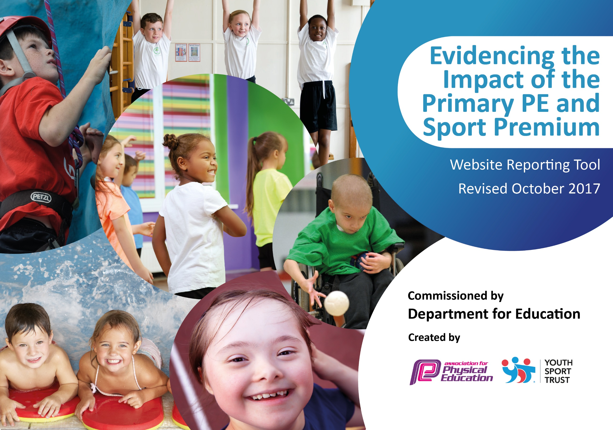

Schools must use the funding to make additional and sustainable improvements to the quality of PE and sport they offer. This means that you should use the Primary PE and Sport Premium to:

- develop or add to the PE and sport activities that your school already offers
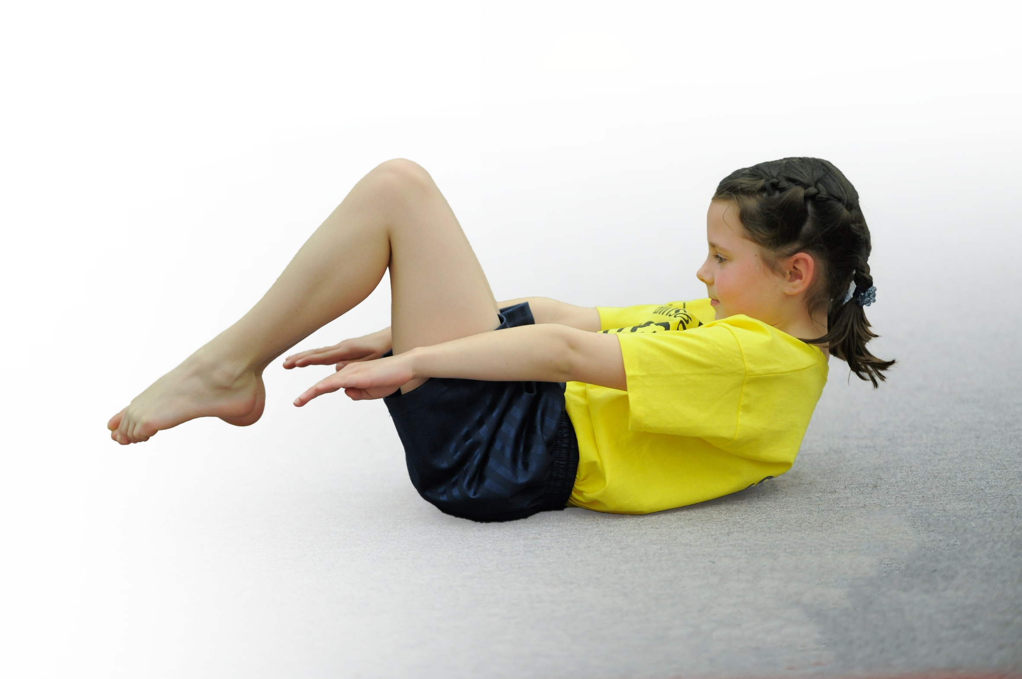
- build capacity and capability within the school to ensure that improvements made now will benefit pupils joining the school in future years

Please visit gov.uk for the revised DfE guidance including the 5 key indicators across which schools should demonstrate an improvement. This document will help you to review your provision and to report your spend. DfE encourages schools to use this template as an effective way of meeting the reporting requirements of the Primary PE and Sport Premium.

We recommend you start by reflecting on the impact of current provision and reviewing the previous spend.
Under the Ofsted Schools Inspection Framework, inspectors will assess how effectively leaders use
the Primary PE and Sport Premium and measure its impact on outcomes for pupils, and how effectively governors hold them to account
for this.

Schools are required to publish details of how they spend this funding as well as on the impact it has on pupils’ PE
and sport participation and attainment.
We recommend regularly updating the table and
publishing it on your website as evidence
of your ongoing review into how you are using the money
to secure maximum, sustainable impact. To see an example of how to complete the table please click HERE.

Support for review and reflection - considering the 5 key indicators from DfE, what development needs are a priority for your setting and your students now and why? Use the space below to reflect on previous spend, identify current need and priorities for the future.

Key achievements to date: | Areas for further improvement and baseline evidence of need:
- Bespoke curriculum for Physical Education.  - Offering a wide range of inspiring extra-curricular activities.  - Incorporating the use of ICT in PE.  - Increased engagement in PE lessons by staff and pupils. | - Ensure that the equipment meets the requirements of the bespoke curriculum.  - Continue to develop staff and offer them the chance to become experts in Physical Education.  - Support all staff in understanding safer practice.  - Provide training for all staff on inclusion and SEN in PE

Action Plan and Budget Tracking
Capture your intended annual spend against the 5 key indicators. Clarify the success criteria and evidence of impact that you intend to measure to evaluate for students today and for the future.

Academic Year: 2019/20 | Total fund allocated: £9000 | Date Updated: 07.07.20
Key indicator 1: The engagement of all pupils in regular physical activity – Chief Medical Officer guidelines recommend that primary school children undertake at least 30 minutes of physical activity a day in school |  |  |  | Percentage of total allocation:
 |  |  |  | 14%
School focus with clarity on intended impact on pupils: | Actions to achieve: | Funding allocated: | Evidence and impact: | Sustainability and suggested next steps:
Pupils to attend the National School Sports Week  Active Lunchtimes | Year 4 children to all attend the National School Sports Week organized by Pennine Sports Partnership.  Staff attending to observe good practice and feed back to the staff team.  All lunchtime staff to be prepared to support children into making active choices incorporating physical activity and undertake training to create their own tool kit for active lunchtimes.  Running club- Lunchtime open club.  Dance club- Lunchtime open club. | £1475  In house under GE contracted hours. | Sadly due to the COVID -19 pandemic children were unable to attend the event this year.  Lunchtime staff received in-house training on how to make lunchtime more active for all children.  *Subject to COVID status, when we are able to mix bubbles. | The academy will be exploring how we can continue to attend alternate competitive events in 2020-2021 academic year.  SLT should work with GE to strengthen links with PE leads in the MAT to invite the other primary schools to competition within our school.  Staff are now all enthusiastically encouraging more children to be active during lunch and the team are beginning to see the impact of this in children’s social behaviors.  My suggestion would be to now refresh this each year along with safer practice training by GE.  Running and Dance were both well attended by pupils in years 1-6.  Future plans to develop showcase or special assembly to add purpose for the club and boost confidence through performance.  Running club children signposted to Park Run.  *We also need redevelop our pupil leadership team for increased success in active lunchtimes. A relaunch of Play Leaders and Sports Crew is needed. GE should work with SLT to identify a lunchtime line for developing the pupil leadership team.  The outdoor provision requires updating. SLT should explore ways we can improve outdoor facilities. Not only for increased engagement in active lunchtimes, but also to support as the outdoor PE provisioned in order to make best possible use of the space.
Key indicator 2: The profile of PE, sport and healthy living being raised across the school as a tool for whole school improvement |  |  |  | Percentage of total allocation:%
 |  |  |  | 66%
GE continue to implement and oversee specific targeted extra-curricular clubs. With support from SM sports.  .  Pennine Sports Partnership committed to membership until March 2021. | Breakfast Sports Club Wednesday and Friday mornings.  Tuesday after school Football club.  Friday Lunchtime Boys Club.  Netball Club targeted G&T A and development B.  Circus Skills targeted disengaged.  Archery Club targeted KS2.  Pennine Sports Partnership (PSP) to support the school in engaging children in active lifestyles.  PSP will provide tailored sessions for various different sports for targeted year groups.  PSP will also offer school attendance to various competitive events through the year.  Finally PSP will work with staff in tailored sessions provide CPD and special assemblies on Sports when requested. | £6010 | With support from SM Sports we have been able to offer the children a wider range of regular clubs.  Places in the Breakfast club were earned over the week for positive behavior while in attendance at the school breakfast club.  Tuesday football was KS2 alternating half termly between year 3 & 4 than 5 & 6.  Friday Lunchtime club was offered as an intervention for KS2 Boys that were exhibiting challenging behaviors. This worked alongside the school behavior policy and was also incorporated in some children’s behavior plans as a reward for improving behavior in all areas of the school. We saw a vast improvement in behavior of individuals in KS2.  Archery (RM) within contracted hours was well attended by KS2 pupils.  Netball (GE) within contracted hours. Originally offered on a Friday saw low numbers but when changed to Monday attendance increased.  Circus skills (GE) within contracted hours. Again a successful club for targeting disengaged pupils (largely KS2 girls).  Due to COVID 19 clubs had to be suspended as such we were unable to compete in the Hi5! Tournament. GE through her connections with various clubs and Kirklees District/County Netball was able to sign post for further development including to Leeds Rhinos boys 7-11 sessions. We remain a Huddersfield Giants Netball Club Partner School.  PSP have continued to work alongside staff to provide children with opportunities and experiences of a range of sports across the school.  Our link person has worked with our Y6 staff to develop skills and knowledge sharing good practice in Yoga, Boxing and Dance. She provided Yoga sessions for Y1 and 2. They also ran a session on active stories for our nursery and reception pupils.  PSP intended to provide multiple opportunities in competitive events, thus raising the profile of sport in school. However due to COVID we were unable to attend events and make best use of the PSP services. | Staff continue to be encouraged to come and observe best practice of both external and internal sports clubs.  A change in staffing structure of breakfast club now means that a member of staff in house is able to lead physical activity during breakfast club due to CPD received shadowing staff from SM Sports for 2019-20 academic year with support from GE lead to AP is now be able to lead on some activities.  SM Sports should continue to support wider staff in developing their skills through observation and team teaching.  Clubs should be continually reviewed by GE to promote success and attendance. PP and SEN pupils should also be actively encouraged to attend extra-curricular clubs.  SM Sports will also continue to support Staff sharing best practice in curriculum PE and in after school and lunchtime clubs.  SM Sports are to lead on Multi-Skills for KS1 &2 in Autumn 1 with pupil voice to reflect the clubs available the reminding 5 half terms.  GE to work with AQ and SLT to identify a suitable candidate in school to take on the role of Archery Club Leader. CPD will be provided.  SM Sports will also continue to support Staff sharing best practice in curriculum PE and in after school and lunchtime clubs.  SM Sports are to lead on Multi-Skills for KS1 &2 in Autumn 1 with pupil voice to reflect the clubs available the reminding 5 half terms.  Again with Circus Skills it would be productive for the children to have a performance to aim for as with Dance. GE to work with AQ and SLT to organize in 2020-2021. Subject to COVID status.  GE should continue to lead on Netball Club as she has significant expertise in this area of PE. I would also suggest we avoid Fridays for this and any other ASC as Fridays have less impact.  Review of membership will be conducted in March 2021. Depending on the climate of competitive sports and COVID 19 SLT will make a final decision then as to the cost V’s impact of the service.  Opportunities for competition should be explored involving other schools within the Multi Academy Trust and local community.

Key indicator 3: Increased confidence, knowledge and skills of all staff in teaching PE and sport |  |  |  | Percentage of total allocation:
 |  |  |  | 4%
School focus with clarity on intended  impact on pupils: | Actions to achieve: | Funding  allocated: | Evidence and impact: | Sustainability and suggested  next steps:
GE to continue to develop full staff CPD. With support from Pennine Sports Partnership continue to support all staff in developing their knowledge of physical activity and sports. | GE to work with PSP to deliver full staff CPD at regular intervals through the year. | £400 | Face to face opportunities for full staff CPD have been limited due to Covid. However GE has been able to support staff by making planning and resources available to all staff. GE has also completed a skills based curriculum with skill ladders to support with staff planning.  Ge has continued to support all staff remotely. Offering links and feedback from webinars and giving regular updates on safer practice in line with government guidance from the afPE.  She has been able to send information and reading for all staff too. | GE has prepared and aims to deliver more regular CPD for staff and create opportunities for staff to observe best practice and team teach sessions in the 2020-2021 year.  GE should also continue to review and update staff and SLT on COVID 19 and Safer Practice.
Key indicator 4: Broader experience of a range of sports and activities offered to all pupils |  |  |  | Percentage of total allocation:9%
School focus with clarity on intended  impact on pupils: | Actions to achieve: | Funding  allocated: | Evidence and impact: | Sustainability and suggested  next steps:
Equipment to be purchased to engage children.  The Bespoke curriculum to be finalized. | Quality equipment should be purchased that supports the bespoke curriculum, provides pupils with engaging active lunches and allows out wide range of clubs to continue to grow.  Pupil voice has played a huge part in developing our bespoke Physical Education Curriculum. Staff need to be confident in the delivery and have understanding of the key skills pupils require for each sport included. | £900 | In order for children to be fully engaged in lessons it is vital they have access to the correct equipment and do not have to wait extended amounts of time to take turns as this can lead to disengagement. | Further investment in equipment is still required to cater for all children in our bespoke Physical Education Curriculum. This is somewhat due to wear and tear. This should be reviewed in the first Sports Inset delivered by GE to ensure all staff have all the required resources to deliver the curriculum.
Key indicator 5: Increased participation in competitive sport |  |  |  | Percentage of total allocation:7%
School focus with clarity on intended  impact on pupils:  Huddersfield Town Girls Football Competition.  Sports Day.  Attending competitions  ***Due to COVID-19 we were unable to attend the spring and summer activities. Sadly this is the busiest time of year for competition organized by one of our partners Pennine Sports. | Actions to achieve:  Girls from Y5 and Y6 to attend the football tournament.  Attend as many competitions as possible with PSP  Provide girls with needed equipment.  Sports day  Due to COVID 19 we were unable to hold our traditional sports day. | Funding  allocated:  £500  £200 | Evidence and impact:  We were able to take some Y5&6 girls to the Huddersfield Town Girls Football Tournament at Soccer City. Despite this being their first ever time playing in a competition the girls really benefited from attending, they played well with superb defending skills too! But even more important than their performance was their conduct. They really conducted themselves well, they won and lost with the same grace. Emotionally it was a real developmental experience for them!  For the girls to attend we needed to provide some PPE- shin pads and suitable socks. We borrowed some from within the MAT but purchased some to stay in school for next time.  As we were unable to have a traditional Sports Day GE worked remotely and with the help of afPE and Youth Sport Trust was able to organize some competitive participation in Virtual Sports Day on Tuesday 7th July. | Sustainability and suggested  next steps:  Should the competition be able to run, we should certainly take at least 1 team again. The growth experience was certainly a valuable experience for our girls. This trip was also very good value for money!  We now have this in school for next year.  Despite being signed up, we decided that we were likely to have increased engagement by re-posting contestants to our school remote learning app allowing for elements of competition to flow through the Home School Learners and the pupils in school in their individual Bubbles.  Next year we hope to return to a traditional Sports Day!

